European Market Bike Purchase Conversion Analysis
Identifying High-Conversion Customer Segments to Improve Marketing Efficiency

Prepared for: VP Marketing, Europe
Prepared by: Inimfonabasi Udomisor
Date: 05 August 2026

Who Actually Buys a Bike?

Out of 300 European customers in the dataset, 49.3% ended up buying a bike. That headline figure hides a lot of movement underneath it — some groups convert well above it, some well below, and a few of the gaps are wide enough to build a strategy around.
Observations
These are the patterns as they sit in the data, before any interpretation.
- Occupation is the sharpest divide: Skilled Manual workers convert at 63.3% (n=30), the highest of any occupation. Management sits at the bottom, 18.8% (n=16) - a 44-point gap between two groups of comparable size.
- Younger customers convert best by age: Young: 56.9% (n=137), Middle Age: 45.6% (n=136), Old: 29.6% (n=27). Conversion falls in a straight line as age bracket rises.
- Lower income converts best by income: Low income: 50.6% (n=241), Average: 40.0% (n=30), Rich: 48.3% (n=29). Low income is both the highest-converting and by far the largest group.
- Short commutes convert best: Short: 53.5% (n=226), Medium: 35.0% (n=40), Long: 38.2% (n=34).
- Gender and marital status show almost no effect: Male 49.3% vs. Female 49.4%; Single 48.7% vs. Married 50.0% — none of these are meaningful drivers on their own.
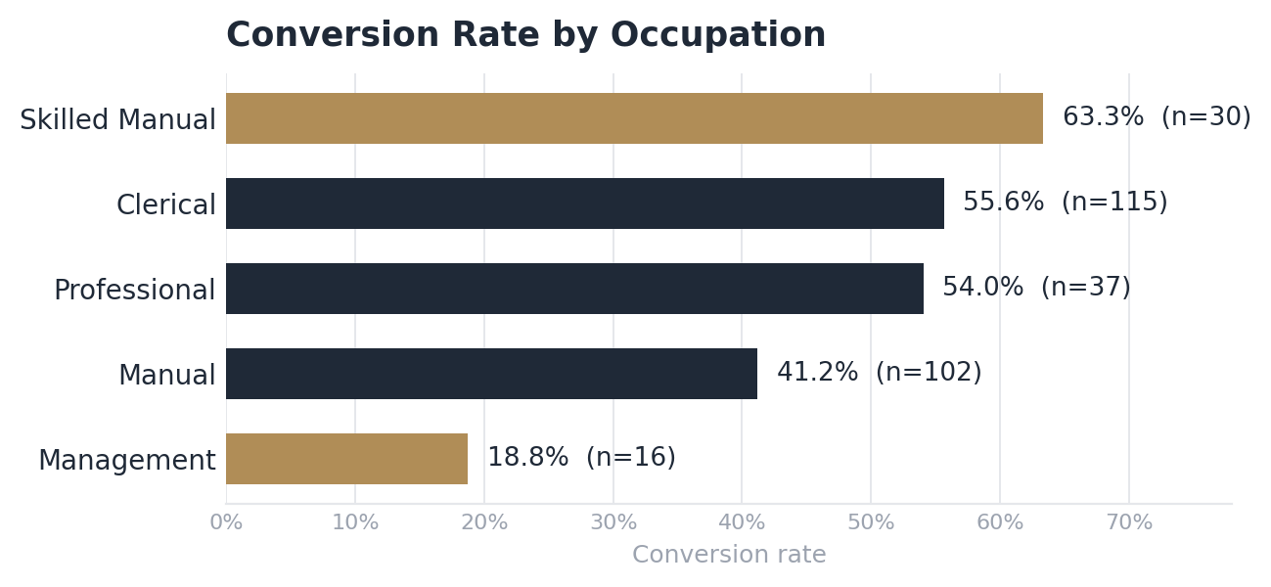
Insights
This is where the observations start to explain each other rather than sit side by side.
- This looks like a practicality purchase, not a leisure one: The fact that low income and short commute both independently out-convert their counterparts suggest customers are weighing the bike as everyday transport, not a discretionary extra.
- Occupation is doing more work than age or income alone: The 44-point Skilled Manual vs. Management gap is larger than any single age or income split, meaning day-to-day work context matters more than demographic profile.
- The strongest combined segments confirm the single-factor story rather than override it: Low Income + Short Commute converts at 53.1% (n=209) which is a large, reliable sample sitting comfortably above the 49.3% average. Young + Clerical (67.1%, n=70) and Young + Skilled Manual (90%, n=10) go further still, though the latter is on a small sample-size base.
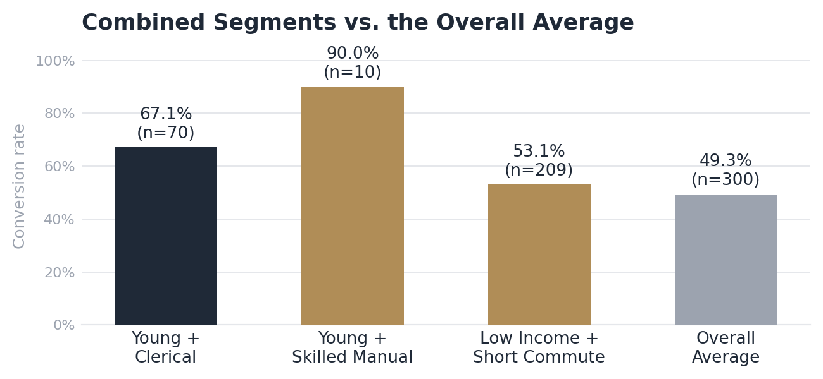
Recommendations for Marketing
- Prioritize: Skilled Manual and Clerical occupations, younger customers, and anyone in the low-income / short-commute bracket. Low Income + Short Commute alone represents 209 of the 300 customers in the dataset, making it the single best return on reach as well as rate.
- Lead with practicality, not lifestyle: Messaging around cost-effective, everyday commuting will land harder with the core segment than premium or recreational positioning.
- Deprioritize: Management and higher-income professionals, and customers with long or medium commutes all convert at roughly half the rate of the top segments or worse, so spending budget here is better redirected.
- Treat Young + Skilled Manual as a test, not a bet: a 90% conversion rate on only 10 customers is worth a small pilot campaign to see if it holds, not a headline budget allocation.
Business Value
Segment-level conversion data like this turns a flat, one-size-fits-all campaign into a targeting decision. Reallocating budget towards Skilled Manual, Clerical, younger, and short-commute customers, who together convert well above the 49.3% baseline should lift overall conversion efficiency without increasing total marketing spend. Just as importantly, it flags where budget is currently being wasted: Management and high-commute segments convert at less than a third of the top segment's rate, so continuing to target them at the same intensity as everyone else is the clearest inefficiency in the current approach.
Limitations
A few of the standout figures (most notably Young + Clerical at 90%) are built on samples under 15 customers and should be treated as directional rather than statistically reliable. The data covers Europe only, so these patterns may not generalize to other regions. And because this is observational, cross-sectional data, the relationships described here are correlations: occupation, income, and commute distance are associated with conversion, but the analysis doesn't establish that changing marketing alone would change these customers' behavior.

Data Dictionary:
AGE BRACKET:
Young: < 30 years
Middle Age: 30 – 59 Years
Old: Above 60 years

INCOME BRACKET:
Low: Below $40,000
Middle: $40,000 - $100,000
Rich: $100,000 and above

